|  |  |  |  |  |  |
| --- | --- | --- | --- | --- | --- |
| Date | 22-Nov-22 | | | Tester Name | Richard Belanger |
| Environment | Penfax - Test | | | Login used | TEST2 |
| Operating System | Windows | Version: | Update: | | |
| Software Used | Edge | Version: | Update: | | |
| Not Applicable | Version: | Update: | | |
| Release version | 22.4.1 | | | | |
| Title | M2.12 Province cannot be Null | | | | |
| Test Type | Regression | | | | |
| Test Scenario | Update an address and leave the Province field blank(Null) | | | | |
|  |  | | | | |
| Expected Results | Error message seen to indicate Province/State field must be valid, when Province field is filled address will update | | | | |
| Pass/Fail | Pass | | | JIRA# | N/A |

Describe your steps with screenshots:

Prior to Update SID = 135367

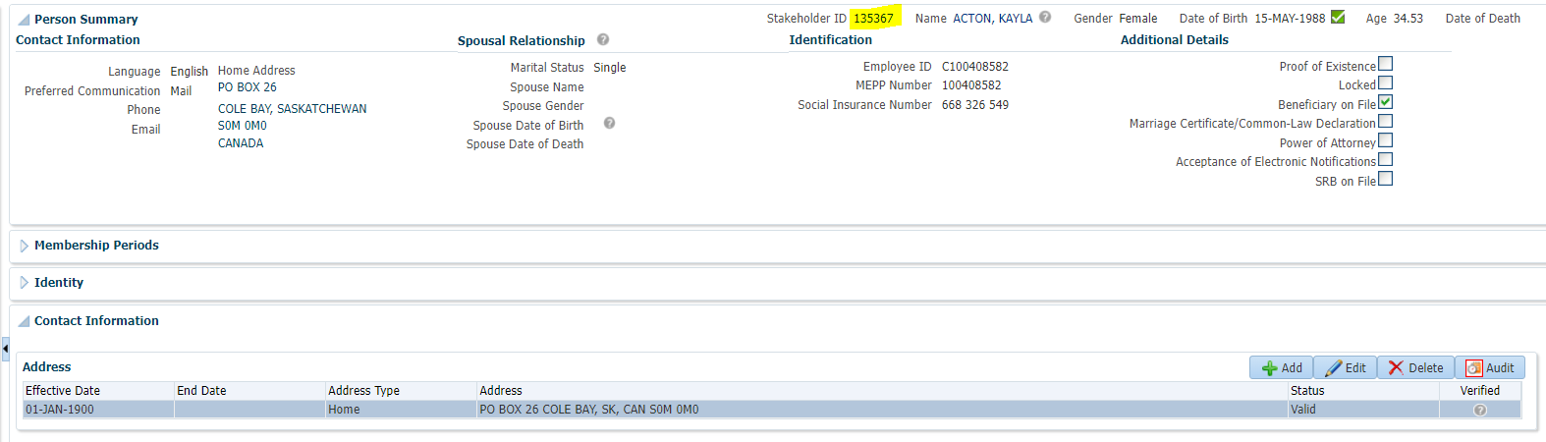

End current address

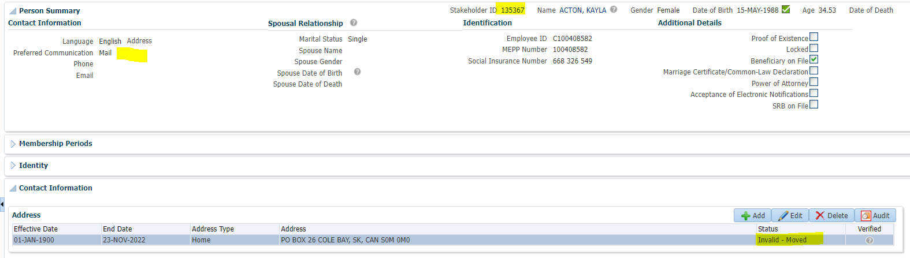

Add new address with no Province

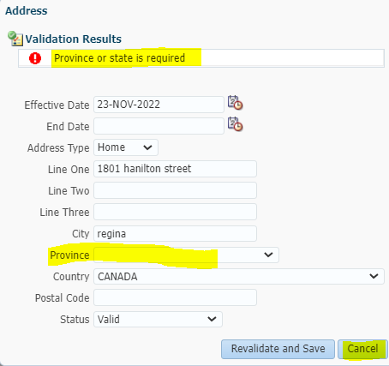

Prior to Update SID = 125632

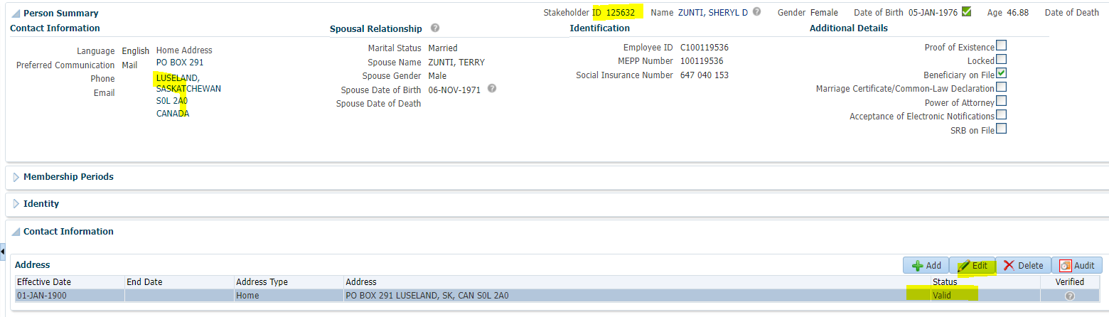

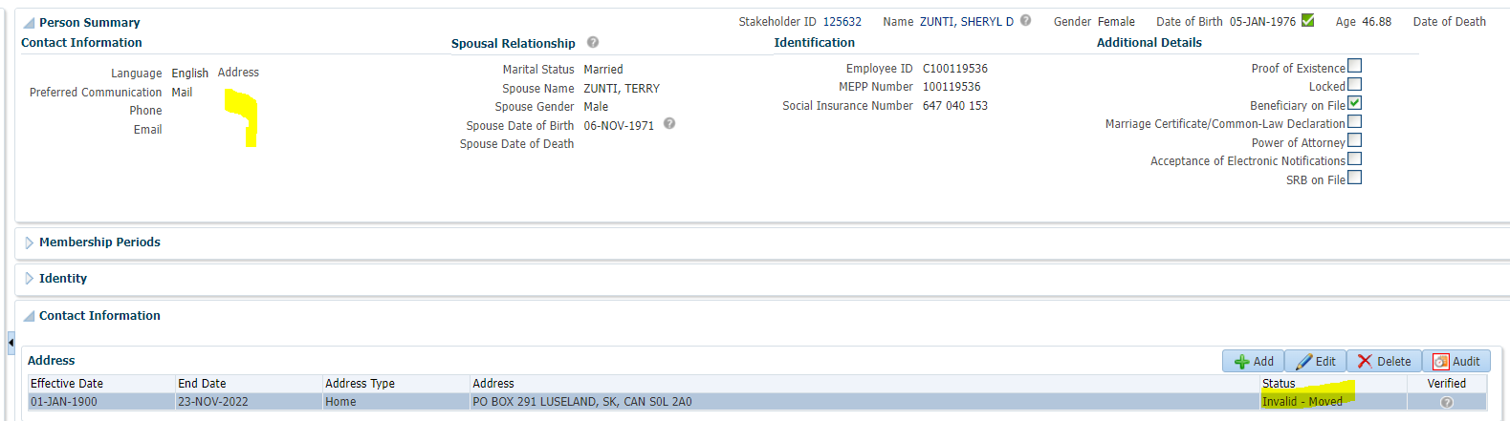

Add new address with no Province

